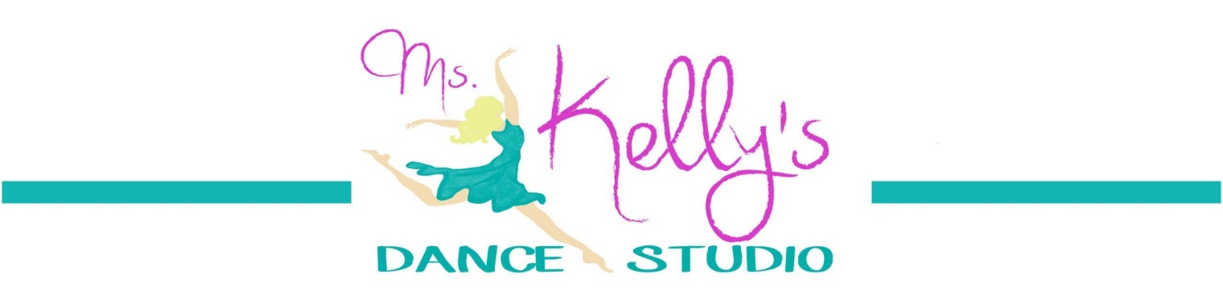
SUMMER DANCE INTENSIVES 2019
SESSION 1: JUNE 3-25 & SESSION 2: JULY 1-23
If you want to improve your technique and gain more confidence, these classes are for you!
PLEASE CHECK YOUR CHOICES
SESSION 2
MONDAYS & TUESDAYS

Grades 3rd-4th
____ 5pm Ballet/Lyrical
____ 6pm Hip Hop

Grades 5th&up
____7pm Ballet/Lyrical
____8pm Hip Hop

SESSION 1
MONDAYS & TUESDAYS

Grades 3rd-4th
____ 5pm Leaps & Turns
____ 6pm Jazz

Grades 5th&up
____7pm Leaps & Turns
____8pm Jazz
PRICES:
1 Genre $60
1 Genre $60 2 Genres $100
2 Genres $100 3 Genres $150
3 Genres $150 4 Genres $200
*FULL PAYMENT REQUIRED AT TIME OF REGISTRATION*
Dancer’s Name ______________________________ Grade ________________
Parent’s Name ______________________________ Phone #______________
Emergency Contact _________________________ Phone # ______________
Cash________ or Check#__________ (payable to Ms. Kelly’s Dance)
Please complete registration form and drop it off at Ms. Kelly’s Dance Studio drop box, scan and email, or mail to:
LOCATION: (830) 688-3315 Mailing address:
6150 Hwy 16 South www.mskellysdance.com 3326 A Hwy 16 South
Bandera, TX 7800 facebook.com/mskellysdance Bandera, TX 78003

